FOR IMMEDIATE RELEASE
Contact:
Will Beaty
Director of Mitigation Markets
Batiste Woods Mitigation Answers, LLC
832-627-1827
huntcfo@aol.com
https://batistewoodsbank.com/
BATISTE CREEK MITIGATION BANK ANNOUNCES GALVESTON DISTRICT APPROVAL FOR INITIAL RELEASE OF RIVERINE FORESTED WETLAND CREDITS IN SOUTHEAST TEXAS
LIBERTY COUNTY, TEXAS — May 20, 2026 — Batiste Woods Mitigation Answers, LLC today announced it has received official regulatory approval from the U.S. Army Corps of Engineers (USACE) Galveston District for the initial release of riverine forested wetland mitigation credits at the Batiste Creek Mitigation Bank. This approval establishes a critical source of pre-approved compensatory mitigation credits to support compliant regional development in Southeast Texas.
The bank’s primary service area covers the Pine Island Bayou Cataloguing Unit (USGS 8-digit HUC 12020007). In addition, the bank provides secondary coverage for the Lower Neches Cataloguing Unit (USGS 8-digit HUC 12020003) and the Village Cataloguing Unit (USGS 8-digit HUC 12020006). The release of these initial credits provides a reliable, legally compliant pathway for infrastructure, commercial, and industrial projects across these major watersheds to efficiently offset unavoidable environmental impacts.
"The Galveston District's approval of this initial credit release at Batiste Creek is a major victory for regional conservation and sustainable development," said Martin O’Neal, CEO of Batiste Woods Mitigation Answers, LLC. "By restoring the natural hydrology and native tree canopy of this riverine system, we are ensuring long-term flood attenuation, water quality improvement, and wildlife habitat protection within the Pine Island Bayou and surrounding Neches River basins."
These newly available riverine forested credits are approved to satisfy compensatory mitigation requirements under Section 404 of the Clean Water Act. The availability of these credits helps Texas developers, municipalities, and industrial operators streamline their environmental permitting and accelerate project timelines.
In accordance with federal mitigation banking standards, this initial credit release confirms that the project has successfully met its foundational administrative, financial, and physical milestones. The entire Batiste Creek Mitigation Bank property is protected in perpetuity by a restrictive covenant and a dedicated long-term management endowment.
Entities seeking to inquire about credit availability, pricing, or specific service area boundaries can find more information by visiting https://batistewoodsbank.com/ or contacting the sales office directly.
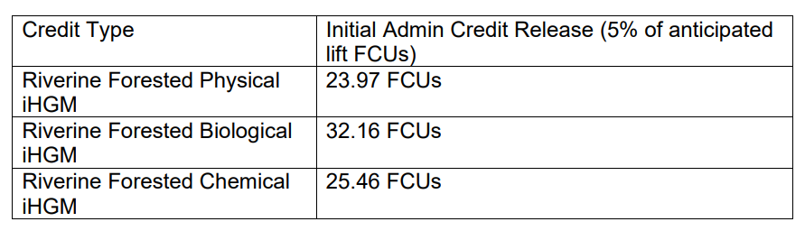
About Batiste Woods Mitigation Answers, LLC
Located in Liberty County, Texas, Batiste Woods Mitigation Answers, LLC is an environmental restoration firm specializing in compensatory mitigation banking. The company designs, permits, and manages high-quality wetland and stream banks to balance economic progress with ecological resilience. For more information, visit https://batistewoodsbank.com/

